Feature file:

Feature: Authentication feature  
 Background:  
 * configure **headers** = **read('classpath:headers.js')** Scenario: Authentication scenario  
 * url **'https://qua.tda.dev.aws.renault.com'** Then path **'/api/v1/users/me'** And method **GET** * print **response**

Add this feature file in xray Jira.

**Background details will be set to precondition type in Jira.**

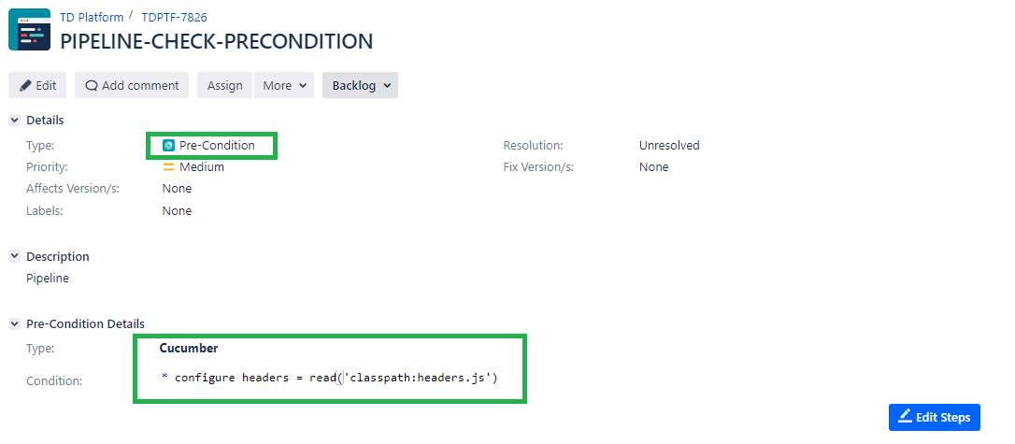

**Scenarios or Scenarios outline will be created as a test type in Jira.**

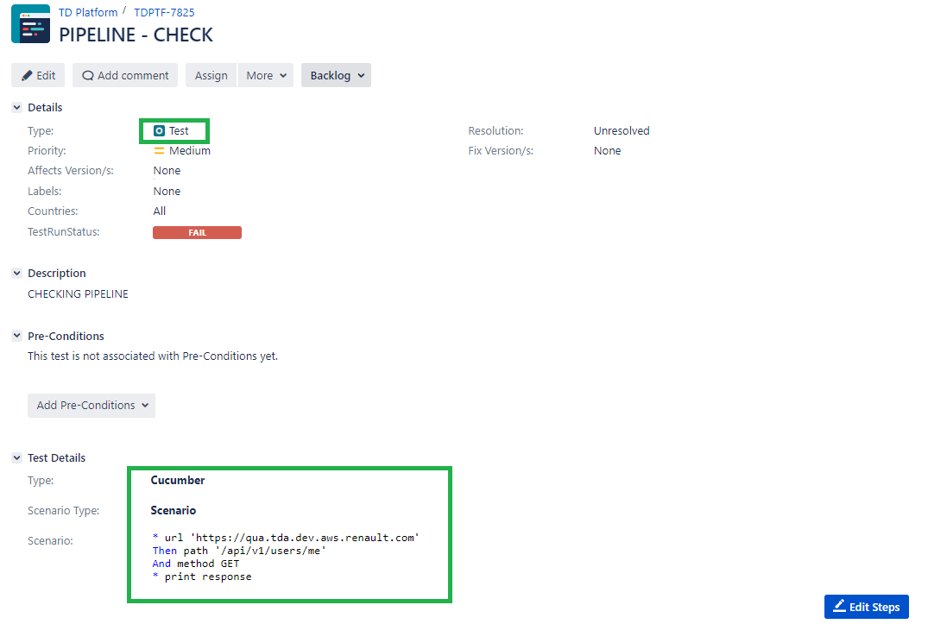

**Precondition should execute first before test. So, link precondition id into test**

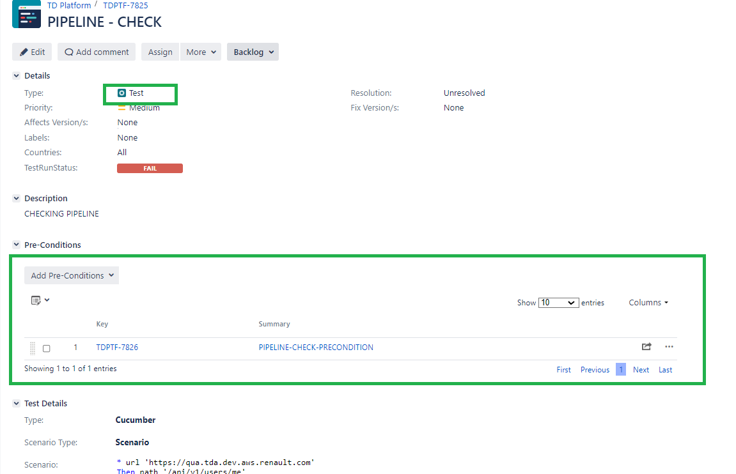

**Create Test plan and link test into test plan for execution.**

